1. Reactions between molecules coordinate diagrams are used to describe how the energy of a molecule (or pair of molecules) changes during a single elementary step in a reaction. Although many changes can occur along reaction path we usually only consider one normal mode or torsional angle in a molecule to describe the progress of the reaction.
2. Using a simple reaction to illustrate your answer state clearly why we can make this simplification?
3. The energy that drives a reaction is provided by collisions between molecules. Explain why the direction from which a molecule is hit by another is important in terms of the probability that the reaction will take place. Illustrate your answer with an example.
4. Explain what is meant by Arrhenius’ ‘activation energy’ EA for a reaction in terms of the distribution of kinetic energy of molecules. Why does increasing the temperature of a reaction affect its rate.
5. Consider the following reaction is shown with a driving force (G) at a particular temperature of +30 kJ mol-1. The mechanism of the reaction appears to be E2 (Elimination – bimolecular).

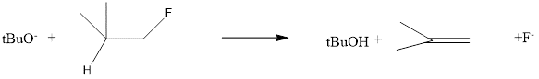

1. Draw an appropriate reaction coordinate diagram for this reaction. In your drawing indicate clearly
   1. Reactants and products
   2. The most appropriate label on the y-axis
   3. An appropriate normal (vibrational) mode or bond angle that defines the reaction coordinate best (there are several possible but indicate only one)
   4. Show clearly in your diagram whether the reaction is exergonic or endergonic
   5. Label Go and G‡ (activation energy) for the forward reaction



1. The reaction of D3-2-methylcyclcohexanone with BuLi and CH3I is shown belowbelow two possible products for the reaction of 2-methylcyclohexanone with butyl lithium and subsequently with CH3I. If the reaction is carried out at 240 K the main product is A. If the reaction is carried out at 320 K, then A and B are formed in a ratio of 1: 8.



1. Identify the kinetic product and the thermodynamic product and draw the structure of the intermediate(s) in each case
2. Explain using an appropriate a reaction coordinate diagram, why the outcome of the reaction changes with temperature.
3. Explain why B is formed in excess at higher temperature.
4. Consider the Eyring equation *k* = (kBT/h)K‡’ = (kBT/h).exp(-G‡/RT) and the Arrhenius equation *k* =  exp(-E/RT).
5.  is the transmission coefficient and has a value between 0 and 1– what does it represent in physical terms?
6. What is meant by the term intrinsic rate constant and how is it related to the lifetime of the activated complex?
7. Explain what is meant by Arrhenius’ ‘activation energy’ EA for a reaction in terms of the distribution of kinetic energy of molecules.
8. The exponential terms in the Arrenhius and Eyring equations look to be similar. Discuss briefly whether they can be directly related or not.
9. Consider the following reaction is shown with a driving force (G) at a particular temperature of -6 kcal mol-1. The mechanism of the reaction appears to be E2 (Elimination – bimolecular).

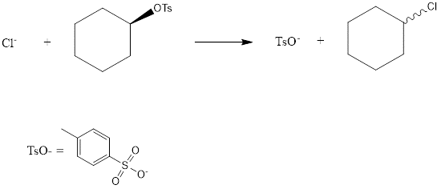

1. Draw an appropriate reaction coordinate diagram for this reaction. In your drawing indicate clearly
   1. Reactants and products
   2. The most appropriate label on the y-axis
   3. An appropriate normal (vibrational) mode or bond angle that defines the reaction coordinate best (there are several possible but indicate only one)
   4. Show clearly in your diagram whether the reaction is exergonic or endergonic
   5. Label Go and G‡ (activation energy) for the forward reaction



1. Using the Gibbs energy equation (G= H  S) and the graph below, explain what is meant by (a) entropy and (b) enthalpy control in the case of two competing reactions

1/T

ln(k h/kBT)